13May26 - SCC discussion
[Mindhive x SCC 13 May26 Transcript.docx]

Mindhive x SCC Meeting
Context: Mindhive is the vendor proposing/implementing MAIA for SCC. SCC is the client, and SCC’s current ERP system is SAP. The meeting focused on SAP data migration, scanned document migration, stock reservation, credit note requisition workflow, and SAP connectivity.

Key Points
- SAP Data Migration
- SCC’s IT vendor is preparing a custom SAP export query.
- Mindhive needs the final data shape, especially order details, batch numbers, and serial number information, to assess migration completeness.
- SCC will check with their IT vendor and revert within the next few days.
- Scanned / SharePoint Documents
- SCC has scanned documents outside SAP.
- Mindhive needs sample files and a rough document catalogue to assess migration complexity.
- These documents may require AI extraction and transformation before they can be imported into MAIA, so this should be scoped separately from SAP data migration.
- Stock Reservation
- MAIA already supports reservation for confirmed orders.
- SCC’s informal/pre-PO stock booking process is currently outside the standard scope.
- Since the informal booking data does not exist in MAIA yet, even notification-based alerts would still require a new data capture/customisation module.
- SCC decided to proceed with the standard/core scope first and revisit informal stock booking after go-live if needed.
- Credit Note Requisition / Approval Workflow
- SCC currently manages credit note requests manually using paper forms and approval signatures before Accounts issues the credit note in SAP.
- Mindhive proposed that MAIA could digitise this as a credit note requisition workflow, where sales/support users raise requests and approvers review them before triggering credit note creation into SAP.
- SCC will first confirm with their SAP vendor whether SAP already has a native requisition function.
- If SAP does not support it natively, SCC may compare whether to customise in SAP or build the workflow in MAIA.
- SAP Connectivity
- Current blocker: connection to SCC’s SAP server due to firewall/server setup.
- Mindhive is coordinating with SCC’s IT vendor to install/configure the listener required for SAP integration.
- Once resolved, Mindhive will spin up SCC’s MAIA instance, perform internal testing, then pass it to SCC for testing.

Action Items
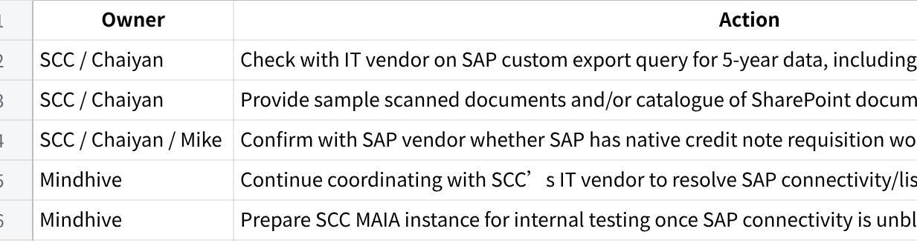
Click the image to view the sheet.

